***Table Of Contents***

|  |  |  |
| --- | --- | --- |
| **CHAPTER NO** | **NAME OF CHAPTER** |  |
| **Chapter 1** | **Introduction** |  |
| **1.1** | **Purpose** |  |
| **1.2** | **Scope** |  |
| **1.3** | **References** |  |
| **Chapter 2** | **Overall Description** |  |
| **2.1** | **User Classes/roles** |  |
| **2.2** | **Operating Environment** |  |
| **2.3** | **Design Architectural Model** |  |
| **Chapter 3** | **Front-end Plan** |  |
| **Chapter 4** | **Back-end Development Plan** |  |
| **Chapter 5** | **Development Plan** |  |
| **5.1** | **Phase 1** |  |
| **5.2** | **Phase 2** |  |
| **5.3** | **Phase 3** |  |
| **5.4** | **Phase 4** |  |
| **Chapter 6** | **Conclusion** |  |

1. Introduction

* 1. **Purpose**

This document is prepared in order to project proposal for VIDEO SHARING WEB APP.On this App people can Make their own Profile, share videos, watch videos , like/dislike and comment on the videos etc.

* 1. **Project Type**

This will be a simple video sharing web application but it will be made based on most popular video sharing web application like Youtube.

**1.3References**

The reference model of this citation is most popular site which is YouTube.   
[www.youtube.com]

**2. Overall Description**

**2.1 User classes/roles & Characteristics**

***Characteristic :***There will be two levels of user and one admin for our system .

***Local User :*** is general user that will be using our system to find their desired videos. They will only see homepage of our system.

***Standard user :*** is user that have right to upload, edit, delete, change the videos. He will able to see the background of our system.

***Admin :*** is also known as system developer and maintainer. They will be able to edit which sites the system will search, depending on whether they think the site is safe, compatible with respective software, the speed at which the site can be searched, and how useful the site is to users, i.e. how many results have come back from that site.

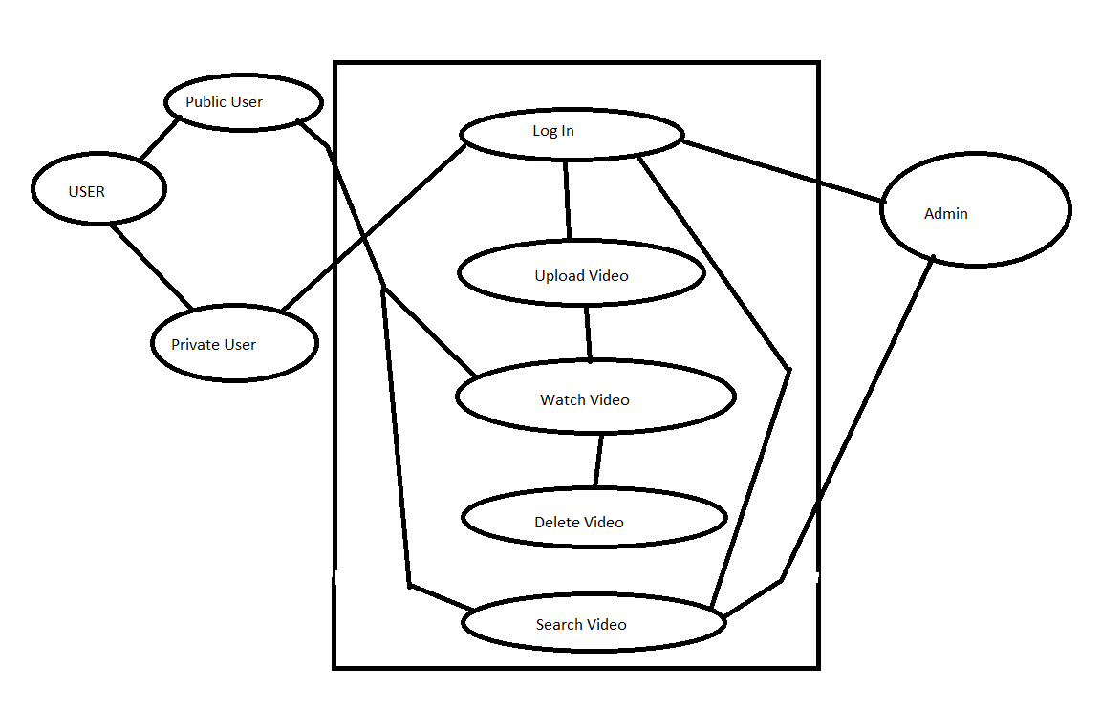

Figure : Simple use-case Diagram

**2.2 Operating Environment**

The system will be portable. This means it will work across different operating systems including Microsoft Windows and Mac OS and a range of Linux platforms.

* Any device like Desktop, Laptop , Mobile, Tablet etc..

* Any version of Google Chrome, Firefox, MS Edge, Safari, or Opera.

**2.3Design Architectural Model**

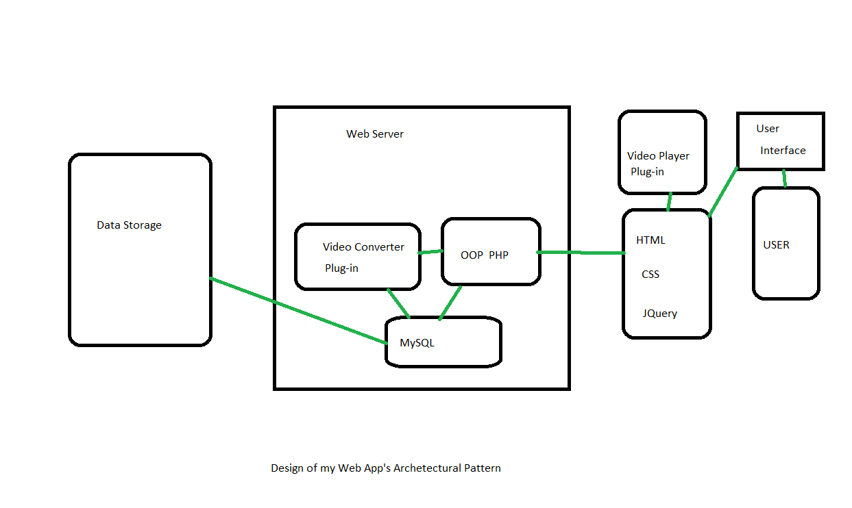

**2.4 Technology Stack**

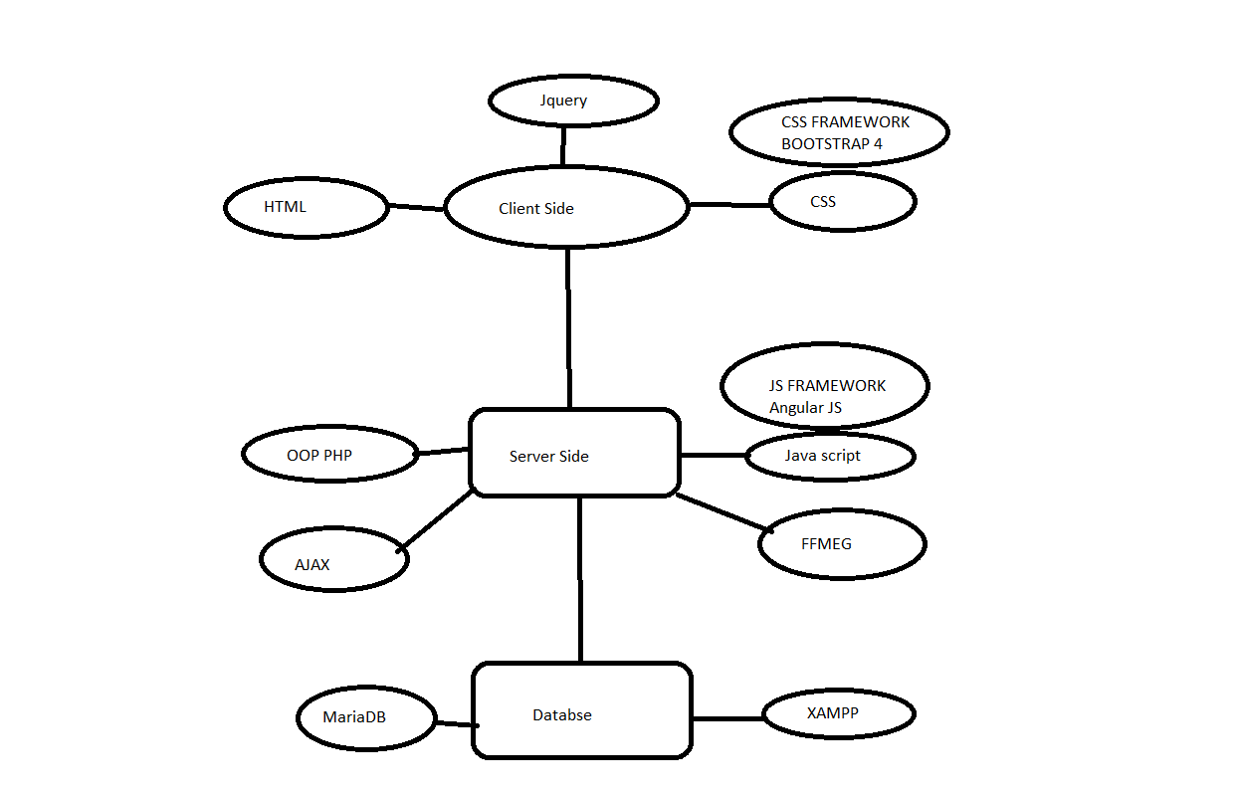

**2.5 Minimum Cost**

**The minimum cost to deploy of this site 5.5 dollar per month without discount. This is actually hosting cost with a free domain. The cost is going higher along with higher data storage.   
Some hosting providers are giving 30% to 60% discount we must buy host from them to minimize our cost.**

**Note:** The most popular site YOUTUBE has their personal DATA CENTER.

**3. Front-end Plan**

Total in 9 page template in plan

1. Index page (video gallery page)
2. Sign In page
3. Sign Up page
4. Profile Page
5. Admin Panel
6. Video Upload Page
7. Video Edit Page
8. Video Delete Page
9. Search result Page

**4. Back-end Development Plan**

1. Account Creating, Password Recover:
   1. Sign up form, verification email.
   2. Login
   3. Forget Password
   4. MySQL Database
2. Profile Management:
   1. DB plan design : MariaDB
   2. Peoples’ Profile
   3. Admin Profile
   4. Others
3. Searching facility:
   1. Video Title Based Search
   2. User Profile name based search (for admin)
4. Video Upload:
   1. Video Converter plug in
   2. Video duration counter plug in
   3. Some modification in PHP.ini for uploading file for the App
5. Video Delete:
   1. Delete video information data from database
   2. Delete video file from datastorage

5. Development Plan

**5.1 Phase 1**

Show our user interface design that covered by HTML, CSS and Media Query. In some situation, I want to use CSS framework BOOTSTRAP 4 then edit that with basic HTML CSS to make my preferable user interface.

**5.2 Phase 2**

This will be my main software development design face. I user here OBJECT ORIENTED PHP, JAVA-SCRIPT , JQUERY and try to use some AJAX.   
I prefer FAÇADE PETTERN to make my design easier and use some plug-in also.

This will be my largest development so I need 3 weeks minimum.

**5.3 Phase 3**

In this face I will show my full project then Sir will say me where to change and how to change.

**5.4 Phase 4**

Final submission of my full project.

6. Conclusion

YouTube allows users to upload video clips, TV show clips, music videos, short and documentary films, movie trailers and educational videosand people can enjoy and watch those as well as our Web App also works as similar way. We hope everyone would like our Web App.